**Community Assessment Report**

**Prepared by**

**Communities That Care Whistler**

**Approved: May 22, 2014**

**Communities That Care –Whistler**

**Vision: “Promote a safe community where residents and guests of all ages are comfortable and secure.”**

**Mission: “To promote positive development for Whistler’s children and young adults.”**

Over time the philosophy of our shared work has continued to be refined and includes: Delivery of “prevention” in a way that is compassionate, supportive, based on evidence and informed by community wisdom given our community’s culture.

**Community Champion:** Norm McPhail, GM, Corporate and Community Services, Resort Municipality of Whistler.

**Community Outreach and Public Relations Lead**: Cathy Jewett

**Current Funder:** Ministry of Children and Family Development

**Host Agency:** Sea to Sky Community Services Society

For more information about Communities That Care – Sea to Sky, please visit the website at <http://ctcseatosky.com/>. For more information or to get involved, please e-mail info@ctcseatosky.com

**Executive Summary**

This report describes the results of the third assessment conducted in Whistler as part of the Communities That Care Process. The Communities That Care system is a way for members of a community to work together to prevent youth health and behavior problems including substance use, delinquency, teen pregnancy, dropping out of school, violence, depression and anxiety. This system was developed by Dr. David Hawkins and Dr. Richard Catalano. It is based on their research, which has identified risk factors that predict youth problem behaviors and protective factors that buffer children from risk and help them succeed over life.

Communities That Care was first adopted in Whistler in 2003 in response to concerns arising from risk related behaviors associated with substance use in youth. Preventing and delaying the use of substances such as alcohol is an important challenge not just in Whistler, but in Canada (Hammond, et al, 2011) and internationally (Eisenberg, Toumbourou, Catalano and Hemphill, 2014). Drawing on a strong evidence base was felt to be a helpful way to support healthy development of our local youth.

A key goal of the Communities That Care effort is to identify which risk factors, protective factors and behavioral health problems are most prevalent in our community and to implement evidence-based programs that address our community’s unique profile. To that end, the Risk and Protective-Factor Assessment work group collected and analyzed data on Whistler. The Community Assessment Report reflects the input of many community members and organizations working together with care, skill and dedication to promote the healthiest possible development of children and youth in our community. The process has contributed to in depth discussions and learning about best and better practices in prevention of child and youth health and behavior issues in relation to our community’s local context.

**Whistler’s Strengths** The data also revealed Whistler’s strengths to build on. In 2006, the protective factors Family Recognition for Pro-social Involvement, Family Opportunities for Pro-social Involvement, and School Recognition for Pro-social Involvement were identified as strengths to build on. Since 2006, there has been a slight increase in the average percentage of students across all grades indicating strength on these protective factors.

**Prevention Priorities**

Based on the local data in 2013, of the six health and behavior concerns addressed, substance use remains a priority for the community. In addition, the following risk factors were identified as community priorities for attention:

1. **Parental Attitudes Favorable toward Alcohol, Tobacco, and other Drug (ATOD) Use**, particularly for students in grades 8-12;
2. **Parental Attitudes Favorable towards Antisocial Behavior**, especially for grades 9-12;
3. **Peer Rewards for Antisocial Behavior**, particularly for grades 9-12; and
4. **Low Perceived Risk of Drug Use**

These risk factors were selected as priorities for prevention action primarily because data indicated that they are significantly elevated in Whistler**.** Significance was determined by examining both grade specific and overall community data.

Community Protective Factor Priorities were also identified for prevention action primarily because data indicated that they are significantly suppressed in Whistler:

1. **Community Rewards for Prosocial Involvement**
2. **Interaction with Prosocial Peers**

This report recommends that the community give particular attention to the risk factors noted above when developing the community’s action plan to and promote positive youth development and prevent youth health & behavior problems. In Whistler, given the high cost of living, the community has agreed that sensitivity to economic pressures facing local families remain on the radar. This means that care be taken to ensure that prevention programs implemented as part of the Communities That Care process are offered free of charge to maximize accessibility to families.

This report will serve as a resource document for communicating the assessment results to stakeholders in our community and will guide the third wave of prevention planning and evaluation by Communities That Care Whistler.

**Whistler Community Assessment Report**

**Introduction**

The **Whistler Community Assessment Report** was written to give an overview of recent data compiled by Communities that Care (CTC) Whistler in regards to self-reported behavior among youth as well as data gathered in the community to give a broader view of youths’ experience in Whistler across the four areas of Community, Family, School and Peer-Individual. CTC Whistler is made up of representatives from Whistler Community Services Society, School District 48, Resort Municipality of Whistler, RCMP, Whistler Blackcomb, Ministry of Children & Families, parents, and community members. The Communities that Care (CTC) system was created by researchers at the University of Washington, Dr. David Hawkins and Dr. Richard Catalano, to help members of a community work together to prevent substance use, delinquency and other problem behavior among youth. Drs. Hawkins and Catalano base their approach to prevention of problem behavior among youth on reducing risk and enhancing protective factors. Communities can use a tool they designed called the *Communities That Care Youth Survey* to obtain data on substance use and a number of risk and protective factors. In 2013, a similar instrument called the *Prevention Needs Assessment Survey* was administered to Whistler public school students in grades 6-12.

**The Community Assessment**

The 2013 *Prevention Needs Assessment Survey*, along with previous survey administrations and archival demographic data, allows the community of Whistler to assess substance use and other problem behaviors and to examine risk and protective factors so that priorities for community action can be set. By using a longitudinal approach, Communities that Care (CTC) Whistler can monitor the effectiveness of prevention strategies that have been implemented and can adjust them to meet current needs. The survey was administered in School District 48 classrooms in October 2013. Students in grades 6-12 participated in the survey on a voluntary basis and were permitted to skip any questions with which they were uncomfortable.

In addition to formal survey data, this assessment report contains data to support indicators identified by Drs. Hawkins and Catalano as valid, reliable measures of risk factors and problem behaviors that have not been measured by the survey. These include Extreme Economic Deprivation, Family Conflict, Teen Pregnancy and School Drop-Out rates. These indicators continue to inform the 2013 report. To this end, the Communities That Care Risk and Protective Factor Assessment workgroup – tasked with interpreting raw survey report data for the purpose of producing this report - have provided supplemental data to support these additional factors.

**The Community of Whistler**

Whistler is a unique community situated in the Sea-to-Sky corridor between Squamish and Pemberton. Whistler, host of many of the 2010 Winter Olympic events, is a luxury resort destination offering activities such as skiing, mountain biking, and golf. Annually, over two million tourists visit Whistler.

Whistler is home to permanent residents, including families with children, seasonal residents, and temporary workers from across the country and around the world. As of 2011, according to *Statistics Canada*, Whistler had a population of approximately 9824 residents with 15.26% of those children under 19 years old and 16.5% in the 25-29 year old age group. Of 3900 private households in Whistler, approximately 21% are comprised of couples with children and 4.4% are lone-parent households.

According to the 2011 National Household Survey (NHS), Whistler has an unemployment rate of 8.7%, which was slightly above the 2011 provincial unemployment rate of 7.5%. In 2010, the median after-tax income of couples with children (average family size of 3.8) was $77, 607 and the median after-tax income of lone parent families (average family size of 3) was $52, 893. In 2011, the average income of Whistler families exceeded the national average. However, the percentage of Whistler residents that fall below the cost of living mark is twice that of the national average. The Whistler Centre for Sustainability (WSC) estimates that the annual cost of a basket of goods for a family of four in Whistler is $60,500, which would require a before-tax income of $72,000 per year.

Mobility, as defined by the number of people that move from one household to another, is higher in Whistler, where 31% of the population moved within the past year, than in the province, where 14.4% of the population moved within the past year. Over a five year period, the percentage of movers in Whistler more than doubled (63%). Of the 2800 Whistler residents who moved within the past year, according to the 2011 census, the majority (63%) moved within Whistler's geographical boundaries.

The risk factor “transitions and mobility” contributes to substance abuse, delinquency and school drop-out (see Appendix 1 for more details).

According to the Foundation Skills Assessment, in 2013, Whistler students demonstrated higher proficiency in reading comprehension, writing and numeracy with the scores of grade 4 and grade 7 Whistler students exceeding the average scores obtained by all students in the province. In 2013, Whistler Secondary students had an eligible grade 12 graduation rate of 98%.

Based on 2011 data, teen pregnancy rates for women aged 15-19 years of age in Howe Sound remained similar to last report (2006) at 13.8/1000. This is higher than the rate of 8.5/1000 in BC and slightly below the coastal rural rate of 14.3 live births/1000 women (Vancouver Coastal Health, 2013).

**Community Priorities**

The *Whistler Community Assessment Report* describes the results of the *Prevention Needs Assessment Survey* administered to public school students in grades 6-12 in the fall of 2013. The 2013 survey of 373 Whistler students follows previous survey administrations in the spring of 2003 (355 students) and of 2006 (374 students). Young adults 18-26 years old were surveyed in 2006 but were not in 2013; therefore there will be no comparison of the data for the young adult age group. The 2013 Prevention Needs Assessment Survey Profile report was prepared by Bach Harrison L.L.C., based in Salt Lake City, Utah[1].

Survey questions were designed to assess use of Alcohol, Tobacco and Other Drugs (ATOD), and participation in Antisocial Behaviors. The survey also examined risk and protective factors that influence delinquency, substance use and other antisocial behavior. Risk factors and protective factors are characteristics of communities, families, and schools which increase or decrease, respectively, the likelihood that youth will engage in substance use and antisocial behavior. Where possible, results from the 2013 *Prevention Needs Assessment Survey* are compared with those from the 2003 and 2006 surveys. In addition, when applicable, results from the Whistler survey are compared with results from students in the entire Sea-to-Sky corridor and with two large normative sample groups.

By comparing survey data from Whistler students with that from a large group of same-age peers, it is possible to determine if, and how, Whistler students' responses differ the norm. As long as characteristics of a group used for normative data are representative of the group being compared and the normative group is sufficiently large, data from the normative group can serve as a statistically rigorous and reliable reference (Salvia & Ysseldyke, 1991). For this survey, the 2013 *Prevention Needs Assessment Survey,* two normative groups were used: a) approximately 460,000 U.S. students who comprise the Bach-Harrison Norm (BH Norm); and b) approximately 50,000 U.S. students who are surveyed annually for the Monitoring the Future (MTF) project.

For the purpose of interpreting survey data, low risk factor scores are desirable, and indicate a reduced level of risk, while high protective factor scores are desirable, indicating a higher level of protection. After the data was interpreted the Risk and Protective Factor Work Group for CTC Whistler decided upon a number of priorities.

**Community Priorities for Alcohol, Tobacco and Other Drug Use (ATOD) Prevention:**

1. **Alcohol** because use by Whistler students remains markedly higher than the Bach Harrison (BH) norm, particularly for students in grades 10-12;
2. **Binge Drinking,** defined as consuming five or more drinks on any one occasion in the past two weeks, as the prevalence of this behavior among Whistler students is also above the BH norm; and
3. **Marijuana** as use of this substance by Whistler students is somewhat above the BH norm, particularly for students in grades 10-12.

In addition to short term harms, developmental research shows that adolescent substance misuse can result in immediate and long term health and behavior problems, particularly substance dependence, mental and physical health problems and disruption to family and social relationships (Hemphill, et al, 2011).

Based on the analysis of the 2003 and 2006 Survey data, the 2006 Community Assessment Report recommended that alcohol, marijuana, and cigarettes and other drugs (crystal meth/ecstasy/cocaine) be priorities for substance use reduction efforts. The results of the 2013 *Prevention Needs Assessment Survey* data indicate that, when the percentage of students using alcohol and marijuana is averaged across grades, use of these substances has decreased. There has also been a percentage decrease in cigarette use across grades. The focus on the use of other drugs, such as ecstasy, was driven by the inclusion of young adults (ages 18-26) in the previous survey. Young adults were not included in the 2013 survey and the use of these drugs by students in grades 6-12 is fortunately very low.

**Community Priorities for Antisocial Behaviors:**

Among surveyed antisocial behaviors, the following behaviors have markedly decreased in prevalence but continue to be among the list of priorities:

1. **Being Drunk or High at School,** a behavior for which the overall number of students involvedis low but which is still occurring among some upper grade students; and
2. **Attacking Someone with Intent to Harm** as it is still prevalent at unacceptable rates in some grades (for example 12.5% of grade 12 students).

In 2006, the risk factors Laws and Norms Favorable to Drug Use, Friends’ Use of Drugs, Poor Family Management, and Parental Attitudes Favorable to Drug Use were identified as priorities. Data from the 2013 Survey indicate that, since 2006, there has been marked improvement on the first two prioritized risk factors: Laws and Norms Favorable to Drug Use and Friends’ Use of Drugs. There has also been improvement on the risk factor Poor Family Management. The final prioritized risk factor Parental Attitudes Favorable to Drug Use has shown some improvement but the average percentage across grades is still higher than the BH norm.

**Community Priorities for Risk Factors are:**

1. **Parental Attitudes Favorable toward Alcohol, Tobacco, and other Drug (ATOD) Use**, particularly for students in grades 8-12;
2. **Parental Attitudes Favorable towards Antisocial Behavior**, especially for grades 9-12; and
3. **Peer Rewards for Antisocial Behavior**, particularly for grades 9-12 where the percentage of Whistler students indicating they have risk on this factor is markedly higher than the BH norm. (See definitions p. 20).
4. **Low Perceived risk of drug use.**

**Community Priorities for Protective Factors are:**

1. **Community Rewards for Prosocial Involvement**
2. **Interaction with Prosocial Peers**

It is noted that the data shows religiosity as the most suppressed protective factor. In local discussions, it was determined that while this factor adds protection, as a guide for future prevention programming that is more universal, other protective factors would be a more useful focus based on our local culture and context.

In 2006, the protective factors Family Recognition for Pro-social Involvement, Family Opportunities for Pro-social Involvement, and School Recognition for Pro-social Involvement were identified as strengths to build on. Since 2006, there has been a slight increase in the average percentage of students across all grades indicating strength on these protective factors.

**Substance Use and Anti Social Behaviour Analysis**

The following sections of the assessment report provide detailed information and analysis of the risk factors, protective factors and problem behaviors among youth attending public school grades 6-12 in Whistler, British Columbia.

**Substance Use Data**

The 2013 *Prevention Needs Assessment Survey* assesses substance use in three ways: ever-used, 30-day use, and heavy use.

The results for 30-day use are the most sensitive indicator of the current level of substance use. Heavy use is measured through survey questions regarding binge drinking, defined as consuming five or more drinks in a row at any time over the past two weeks, and by asking whether respondents smoke a half-pack or more of cigarettes per day.

Survey results obtained from the Whistler 2013 survey are compared to those obtained from the local surveys administered in 2003 and 2006 and to the 2013 survey results for all students in the Sea-to-Sky corridor. In addition, Whistler survey results are compared to those obtained from a large national (U.S.) survey, the *Monitoring the Future* (MTF) survey. Each year the MTF survey, conducted by the Survey Research Center at the University of Michigan, is given to a total of 50,000 students in grades 8, 10, and 12.

**Substance Use: 30-day Use**

Recent (30-day use) of Alcohol, Tobacco, or Other Drugs (ATOD) was low for Whistler students in grades 6 and 7. Whistler grade 6 students who completed the survey did not indicate any use of substances over the past 30 days. This is an improvement over the 2006 survey results in which 9.3% of grade 6 respondents reported recent use of inhalants. Among students in grade 7, 3% indicated they consumed alcohol and 1.5% indicated they used prescription stimulants or amphetamine without approval from a physician. Of the 67 grade 7 students who completed the survey, these percentages translate to two students who reported consuming alcohol and one student who reported taking stimulants or amphetamine without a prescription.

**Alcohol and Marijuana**

Alcohol and marijuana are the two substances for which survey respondents indicated significant use over the past 30 days. Chart 1 compares current ATOD[2] use for Whistler and the Sea-to-Sky corridor with use indicated in the past two survey administrations (2003 and 2006). In general, substance use has decreased since 2006. However, there are still some areas of concern when data are looked at by grade level. Of particular note, the percentage of Whistler students using alcohol jumps from 19.4% of respondents in grade 9 to 61.7% of respondents in grade 10. Recent (30-day) use of marijuana by Whistler survey respondents shows a similar trend to their 30-day use of alcohol with a large jump between the percentage of grade 9 students (5.6%) and grade 10 students (36.2%) who reported recent use of marijuana.

Whistler students also indicated more use of alcohol and marijuana and more incidents of binge drinking than did students who took the *Monitoring the Future* (MTF) survey (see Chart 2). By comparing the survey results of Whistler students in grades 8, 10, and 12 to those of MTF[3] respondents in grades 8, 10, and 12, Chart 2 clearly indicates that the use of alcohol and marijuana by Whistler students is above the norm.

Age seems to be a particularly significant factor for substance use in Whistler. Charts 1 and 2 are weighted averages across grade levels and do not depict the large shift in substance use that occurs between the middle and high school grades. While it is expected that high school students would engage in more substance use than would middle school students, the shift for Whistler students is greater than for the normative group of MTF survey respondents. In grade 8, the percentage of Whistler students (11.1%) who reported alcohol use in the past 30 days was less than the percentage of *Monitoring the Future* (MTF) survey respondents (12.7%) who reported 30-day alcohol use. In addition, in both grades 8 and 9, as compared to all student respondents in the Sea-to Sky corridor, a smaller percentage of Whistler students reported consuming alcohol in the past 30 days. However, by grade 10, when compared to all Sea-to-Sky students and students who took the MTF survey, a larger percentage of Whistler students have consumed alcohol over the past 30 days. A similar trend exists for marijuana use. A smaller percentage of grade 8 Whistler students (3.2%) than MTF students (7.2%) reported recent use of marijuana. In grades 10 and 12, the percentage of Whistler students who reported recently using marijuana was larger than the percentages of MTF grade 10 and 12 students who indicated that they had used marijuana within the past 30 days.

One of the many factors that affect whether or not students engage in substance use is the availability of alcohol, tobacco, and other drugs. Several survey questions asked students about the ease of obtaining drugs. Consistent with the use of marijuana significantly increasing with student age, the percentage of students who say that it is “very hard” to get marijuana decreases linearly from 90.9% in grade 6 to 10.3% in grade 12.

Students who indicated they had used alcohol answered more detailed questions as to where they obtained alcohol they had consumed within the past year. Given the small number of students, especially in lower grades, who indicated they had consumed alcohol, caution should be used in making inferences to all Whistler youth. Among the five grade 7 students who indicated that they had consumed alcohol within the past year, the most common response to where they obtained alcohol was that they got it either from home with their parents’ permission (n=4) or from another family member or relative (n=3). Grade 8 students indicated they obtained alcohol from parents or another relative but also indicated that they obtained alcohol either from home without permission, from someone over 21 years old, or at a party. From grades 9-12, students were most likely to report that they obtained alcohol at a party. The second most common response for this age group was that they obtained alcohol from someone 21 years or older.

**Tobacco**

The 2013 *Prevention Needs Assessment Survey* asked students whether they smoked cigarettes or chewed tobacco. Students in grades 7 and 8 did not report using any tobacco in the past 30 days. In general, the use of tobacco increased with student age but no more than five students in any grade reported recently smoking a cigarette. The grade with the most prevalent use of tobacco was grade 11, which had approximately seven students who reported recent use of chewing tobacco.

**Chart 1** 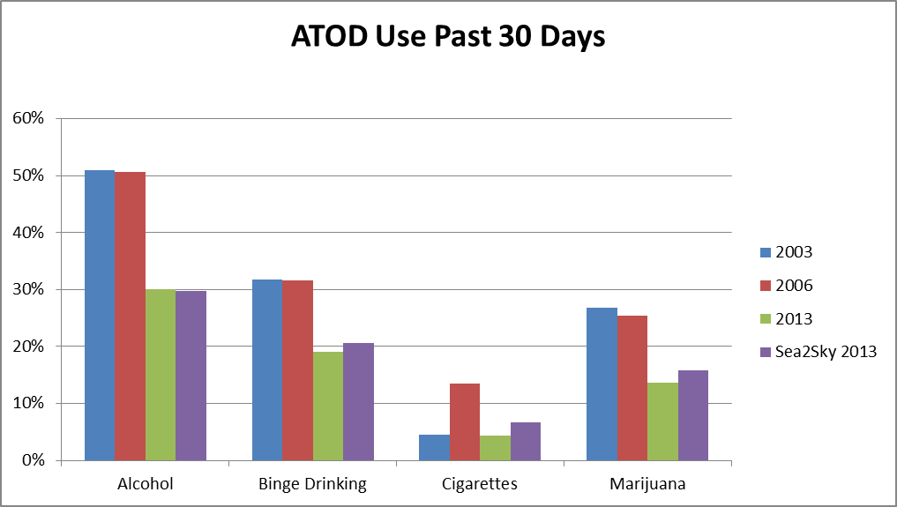

**Percentage of Students**

**ATOD- Alcohol, Tobacco and Other Drug**

**Chart 2**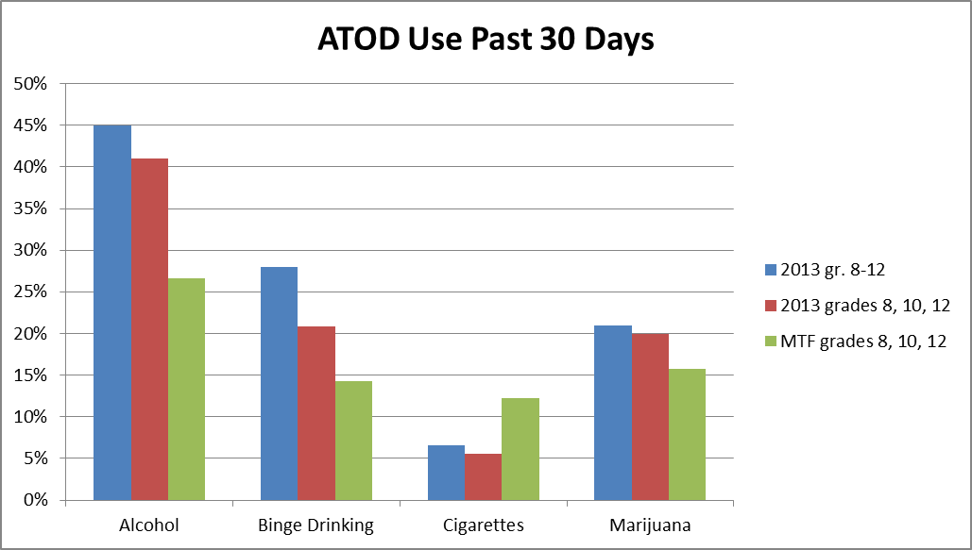

**Percentage of Students**

**MTF- Monitoring for the Future-** Survey conducted by the Survey Research Center at the University of Michigan is given to a total of 50,000 students in grades 8, 10, and 12.

**Other Drugs**

It is encouraging that use of highly addictive and potentially adulterated street drugs, such as heroin, methamphetamine, and cocaine, is extremely low among Whistler youth in grades 6-12. Few students reported use of street drugs (hallucinogens, cocaine, methamphetamine, heroin, and MDMA “ecstasy”) in the past 30 days. Specifically, no students indicated recent use of heroin, one grade 11 student reported using cocaine, and one grade 11 student reported using methamphetamine. One grade 8 student and two grade 11 students reported recent use of hallucinogens. The street drug used by the most students, four students from grades 10-12, was MDMA (Ecstasy). Most students (89.6%) reported that cocaine is either “very hard” (72.8%) or “sort of hard” (16.8%) to obtain. In contrast, a smaller percentage of students (63.9%) reported that marijuana is “very hard” (49.7%) or “sort of hard” (14.2%) to obtain.

In general, students reported slightly more recent use of prescription drugs (used without orders from a physician) than recent use of street drugs. Six students in grades 8-12 indicated they had recently used amphetamines, three students indicated they had recently used sedatives, four students indicated they had recently used prescription narcotics, and one grade 12 student reported recent use of prescription tranquilizers. Data on where the students obtained the prescription drugs is not available.

**Heavy Alcohol and Tobacco Use**

Heavy alcohol use, in this case defined as binge drinking rather than chronic use, was measured by asking students whether they had consumed five or more drinks in a row in the past two weeks. No Whistler students in grade 6 reported binge drinking. According to the 2013 youth survey data, the incidence of binge drinking increased with age peaking in grade 11 with 61.2% of respondents reporting having consumed 5 or more drinks in a row over the past two weeks. Among grade 11 survey respondents, binge drinking was more prevalent for Whistler students (61.2%) than for Sea-to-Sky students (43.9%). By grade 12, the percentage of Whistler students who reported binge drinking (34.4%) was lower than that of Sea-to-Sky students (50.7%). In grades 10 and 12, the percentage of Whistler and Sea-to-Sky students reporting binge drinking was much higher than that reported by *Monitoring the Future* *(MTF)* survey respondents. The prevalence of binge drinking among Whistler students has decreased since the 2006 survey when 71.1% of grade 11 students and 75% of grade 12 students reported having consumed more than five drinks in a row.

Youth alcohol misuse is among the highest contributor to preventable mortality and morbidity in developed and developing nations….It is important to monitor adolescent alcohol and drug use as these behaviors contribute not just to problems in adolescence but also increase the likelihood of harmful alcohol and drug use later in life (In Toumbourou, et al, 2009).

Heavy tobacco use was measured by asking students if they had smoked at least a pack of cigarettes per day in the past 30 days. The percentage of students reporting having smoked at least a pack of cigarettes per day was very low (only one student in each of grades 10, 11, and 12) and was similar to the percentages reported by Sea-to-Sky students and *Monitoring the Future* survey respondents.

**Reported Antisocial Behaviors**

Antisocial behaviors are behaviors that run counter to established norms of good behavior(Channing Bete, 2003, p. 41). The CTC Youth Survey measures 8 other problem or antisocial behaviors. In contrast with prevalence rates for substance use, antisocial behavior rates are for the incidence of behavior over the past 12 months (Bach Harrison, 2013, p. 7). Antisocial behaviors have decreased among Whistler youth since the 2003 and 2006 survey administrations (see Chart 3). Compared to Sea to Sky students as a whole and to students who comprise the BH Norm, Whistler students engage in fewer antisocial behaviors.

Being Drunk or High at School, a surveyed behavior that was made the top priority as a result of the 2006 survey, has decreased significantly from 20.6% in 2006 to 7.26% in 2013. This behavior is markedly more prevalent among older students as no students in grades 6, 7 or 8 reported being drunk or high at school but 30.3% of grade 12 reported this behavior. One of the other behaviors targeted after the 2006 survey was Attacking Someone with Intent to Harm. The prevalence of this behavior has decreased from 9.8% in 2006 to 3.1% in 2013. Being Suspended from School was a factor that was made a priority in 2006. The percentage of students suspended from school has decreased from 13.3% in 2006 to 1.36% in 2013. This large improvement may be due, in part, to a change in school policy. The presence of students under the influence of substances at school is unhelpful to positive youth development and school culture. While the behavior may take place in or near school property, we view this behavior and the response as community issues.

**Chart 3**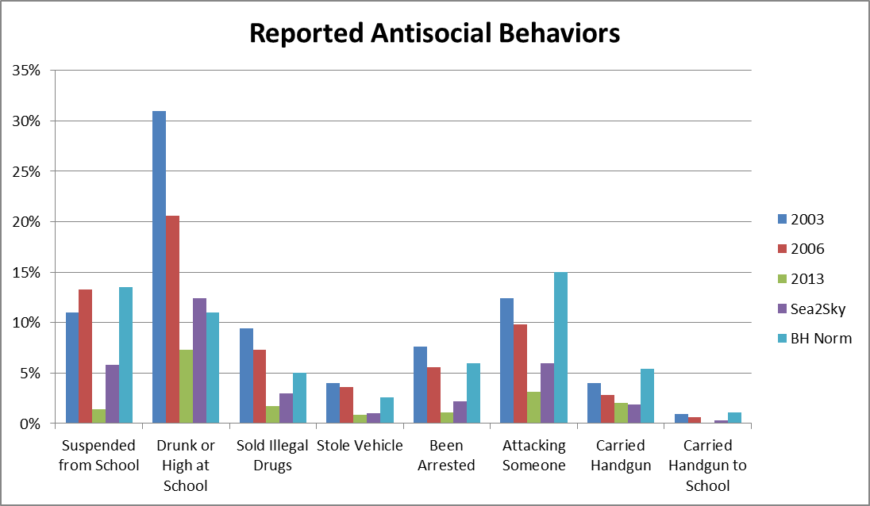

**Percentage of Students**

**Risk and Protective Factors Data Analysis**

Risk factors that, when present, increase the likelihood that a problem behavior will occur have been identified by researchers at the University of Washington. These risk factors for youth problem behavior are characteristics of school, community, and family environments. In addition, characteristics of individuals and their peer groups have been found to affect substance use and other problem behaviors. Thus, risk factors measured in the survey are divided into four domains: community, family, school, and peer-individual. Protective factors, categorized into the same four domains, exert a positive influence and either directly reduce risky or problem behaviors or indirectly protect youth by mediating or moderating the negative influence of risk factors. The effect of these risk and protective factors has been substantiated by many peer-reviewed research studies (see Appendix 1).

In the following sections, data obtained from risk and protective factor questions on the 2013 *Prevention Needs Assessment Survey* administered to Whistler students by Communities that Care (CTC) is examined using weighted average percentage scores for each grade. These average percentages are then compared to those obtained from the 2006 survey. They are also compared to percentages referred to as the Bach Harrison Norm (BH Norm). As mentioned previously, the BH Norm, developed by Bach Harrison L.L.C., is derived from a survey database of approximately 460,000 students.

**Chart 4**

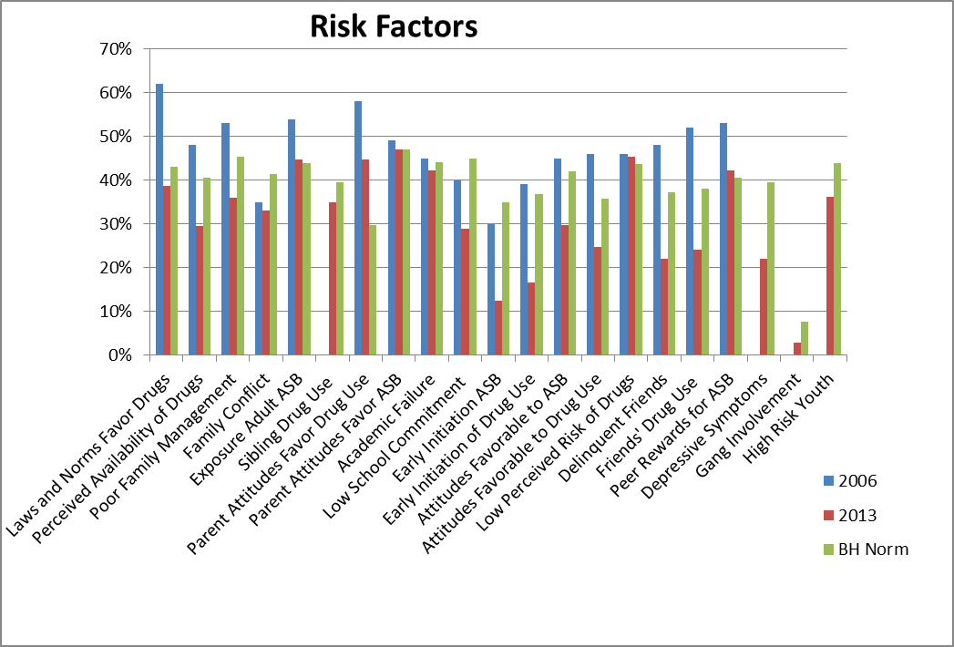

**Percentage of Students**

**Community Domain**

The risk factors measured in the community domain are Laws and Norms Favorable to Drug Use and Perceived Availability of Drugs. Normative attitudes about drug use and local laws and policies, such as the drinking age and alcohol and cigarette taxes, have been shown to affect rates of substance use. The Laws and Norms Favorable to Drug Use factor was identified as a priority concern after the 2006 survey because the percentage of students in grades 10-12 with this risk factor ranged from 74% to 89%. The 2013 survey results are encouraging as the percentage of students in grades 10-12 perceiving that laws and norms favor drug use ranged from 55.3% to 59.5%.

Low risk drinking guidelines for adults. Reduce long-term health risks by drinking no more than:

10 drinks a week for women, with no more than 2 drinks a day most days

15 drinks a week for men, with no more than 3 drinks a day most days

Plan non-drinking days every week to avoid

developing a habit. For more references including standard drink sizes and times when zero drinks is the most appropriate option, visit: http://www.camh.ca/en/hospital/health_information/a_z_mental_health_and_addiction_information/alcohol/Pages/low_risk_drinking_guidelines.aspx

Across grades 6-12, a weighted average of 29.5% of Whistler students responded that drugs were easy to obtain. This result suggests a trend in a positive direction as the results of the 2006 survey indicated that an average of 48% of students perceived drugs to be easily available. The percentage of grade 12 students with the Perceived Availability of Drugs risk factor decreased from 67.5% in 2006 to 44.8% in 2013.

**Family Domain**

The family domain consists of six risk factors: Poor Family Management, Family Conflict, Sibling Drug Use, Exposure to Adult Antisocial Behavior, Parental Attitudes Favorable to Antisocial Behavior, and Parental Attitudes Favorable to ATOD Use. The weighted percentage values for risk factors can be seen in Chart 4. Some differences emerge when data is reviewed by grade (Chart 5).

Compared to the BH Norm, fewer Whistler students are subjected to family conflict. The Poor Family Management risk factor portrays whether families have clear rules, monitor their children’s behavior, and implement punishment that is too harsh, lax, or inconsistent. In 2006, Poor Family Management was identified as a priority risk factor as over 50% of students, with the exception of grade 7, reported risk in this area. Results of the 2013 survey indicate that fewer students report poor family management risk as the largest percentage of students indicating risk on this factor was 47.8% for grade 11. From grades 6 through 10, as compared to Sea-to-Sky students and the BH Norm, the 2013 survey results indicate that a smaller percentage of Whistler students’ families demonstrate poor family management. However, this trend reverses in grades 11 and 12, with these students reporting more problems with family management than Sea-to-Sky or BH Norm respondents. When students’ responses to individual survey questions are examined, they indicate that over half of families do not have clear rules regarding alcohol use and, in grade 12, over one-third of student respondents indicated that their families do not have clear rules regarding drug use. The 2013 survey results indicate that Whistler students’ responses to questions pertaining to sibling drug use are similar to those of Sea-to-Sky students and BH Norm survey respondents.

Another factor that was identified as a priority as a result of the 2006 survey was Parental Attitudes Favoring ATOD Use. Research related to this factor has found that when parents use drugs or are heavy users of alcohol or are tolerant of their children’s use of drugs or alcohol, their children engage in more substance use.

The weighted average percent for this factor decreased from 58% in 2006 to 44.7% in 2013 and remains significantly higher than the BH Norm. Similarly, parent attitudes and behavior toward drugs, crime and violence influence the attitudes and behavior of their children. When parents are tolerant of their children’s illegal behavior, their children are more likely to engage in delinquent behavior (Appendix 1). The weighted average for the factor Parental Attitudes Favoring Antisocial Behavior remained relatively consistent from 2006 (49%) to 2013 (47%). Chart 5 shows an interesting trend in the two parental attitude risk factors for Whistler data relative to Sea to Sky and BH Norm data. With parental attitudes towards drug use, Whistler students show less risk until grade 8 and then appear to have more risk on this factor. With parental attitudes towards antisocial behavior, Whistler students show less risk until grade 9 and then appear to have more risk on this factor.

**Chart 5** 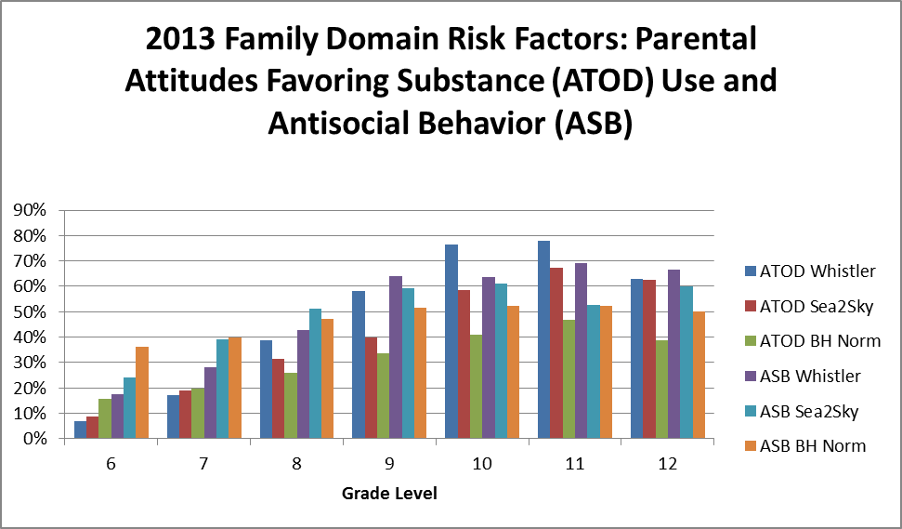

**Percentage of Students**

**ATOD- Alcohol, Tobacco and Other Drug  
 ASB- Antisocial Behaviour**

**School Domain**

The two school domain factors are Poor Academic Performance (Academic Failure) and Lack of Commitment to School. Academic failure beginning in late elementary school increases the rate of drug use and of delinquency (Centre for Communities That Care, 2013, p.5; Crosnoe, 2006). Results from the 2013 survey indicate that Whistler students do not have elevated risk of academic failure as, for all grade levels surveyed, the percentage of students with risk on this factor is either lower than or within a few percentage points of the BH Norm. This data tracks with data from the BC Foundation Skills Assessment in which, compared to all BC grade 7 students, a larger percentage of grade 7 Whistler public school students meet or exceed expected performance levels. Lack of commitment to school is also correlated to drug use. Fortunately, the factor Lack of Commitment to School does not appear to be a prevalent risk factor among Whistler students.

**Peer-Individual Domain**

For the three risk factors, Early Initiation of Antisocial Behavior, Early Initiation of Drug Use, and Friends’ Delinquent Behavior, Whistler students who completed the 2013 *Prevention Needs Assessment Survey* demonstrate a lower percentage of risk than do Sea-to-Sky students or students who comprise the BH Norm sample. Research has found that onset of drug use prior to the age of 15 is a consistent predictor of later drug use. Young people who start drug use before age 15 have twice the risk of drug problems than those who start after age 19 (Catalano et al., 2011; Gil, Wagner, & Tubman, 2004; Gottfredson, 2001; Grant, Stinson, & Harford, 2001; Kandel, 1982; Palmer et al., 2009; Rachal et al., 1982; Robins, 1978; Stone et al., 2012; Zucker, 2008 In Centre for Communities That Care.) The percentage of Whistler students under 15 years old who reported risk on this factor ranged from 0% of grade 7 students to 22.5% of grade 9 students. Friends’ Use of Drugs, a factor that, as a result of the 2006 survey was identified as a priority for community action, showed marked decreases in the percentages of 2013 students showing risk on this factor.

Two factors measured respondents’ attitudes. As compared to results of the 2006 survey, there has been a notable decrease in the percentage of students reporting favorable attitudes towards drug use and towards antisocial behavior. Students with favorable attitudes towards drugs and lower perceived risks associated with drugs are more likely to engage in substance use. Similarly, youth who report favorable attitudes towards delinquent or violent behavior are more likely to later engage in such behavior. The percentage of Whistler grade 6-8 students reporting favorable attitudes towards drug use and antisocial behavior is markedly lower than the percentage of Sea-to-Sky and BH Norm respondents reporting favorable attitudes towards drugs and antisocial behavior. However, starting in grade 9, Whistler students reporting favorable attitudes towards drug use and antisocial behavior increases and often exceeds that reported by BH Norm respondents.

Youth who believe their friends would approve and even admire their drug use or other delinquent behavior are at elevated risk for substance use and antisocial behaviors. The risk factor, Peer Rewards for Antisocial Behavior, noted as elevated in the 2003 and 2006 surveys, has shown some improvement when the responses of all Whistler students are considered. The percentage of students showing risk on the Peer Rewards for Antisocial Behavior factor increase after grade 9, jumping from 34.4% of grade 8 students to 62.5% of grade 9 students. The percentage of 2013 grade 11 survey respondents (68%) showing risk on this factor is similar to the percentage of grade 11 students (67%) showing risk in 2006. However, the percentage of 2013 grade 12 students (69.7%) reporting peer rewards for antisocial behavior decreased from the percentage of 2006 grade 12 students (88%) reporting risk on this factor.

As compared to Sea-to-Sky students and BH Norm respondents, Whistler students also show less risk on the Depressive Symptoms risk factor, a factor that was not assessed in previous Whistler survey administrations. However, this is an important factor and a significant number of students reported depressive symptoms (33.3% of grade 12 students).

High risk youth is defined as the percentage of students who have more than a specified number of risk factors operating in their lives. For grade 6, for which five or more risk factors define high risk youth, the percentage of Whistler respondents in this category (19.7%) is markedly lower than the percentage of Sea-to-Sky respondents (32.8%) or BH Norm respondents (44.1%) considered to be high risk. For grades 7-9, six or more factors define high risk youth. For these grades, the percentage of Whistler students defined as high risk youth increases but is still smaller than the percentage of Sea-To-Sky students and BH Norm respondents defined as high risk youth. For grades 10-12, when seven or more factors define high risk youth, the percentage of Whistler students in this category slightly exceeds the percentage of BH Norm respondents especially in grade 10 where 56% of Whistler students and 43.7% of BH Norm respondents are categorized as high risk youth.

**Protective Factors**

Protective factors are also categorized into four domains: community, family, school, and peer-individual. Chart 6 depicts survey results for protective factors. The 2013 *Prevention Needs Assessment Survey* results are compared to 2006 Whistler survey results and to the BH Norm.

**Chart 6**

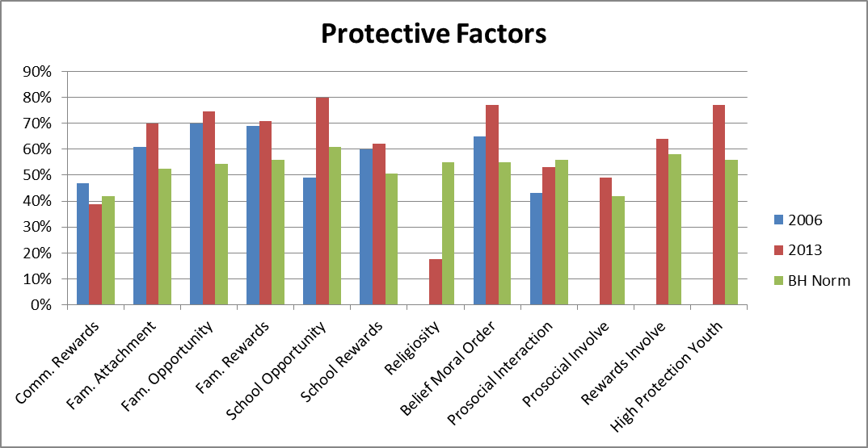

**Percentage of Students**

**Community Domain**

For the 2013 survey, the only factor assessed in the community domain was Community Rewards for Prosocial Involvement. Research has shown that youth who perceive greater rewards and recognition for prosocial involvement in the community are more likely to participate in these activities and less likely to engage in substance use (Channing Bete, 2003p. 13). The weighted average for this factor (39%) decreased slightly since the 2006 survey (47%).

**Family Domain**

The family domain consists of three factors: Family Attachment, Opportunity for Prosocial Involvement, and Rewards for Prosocial Involvement. In 2013, the percentage of Whistler respondents who indicated close attachment to their family, assessed through questions that asked respondents if they feel close to and enjoy spending time with their mother and father, increased from 61% in 2006 to 70% in 2013. This score on the Family Attachment factor is higher than the BH Norm and perhaps a reflection of the shared recreational opportunities available to Whistler families. As can be seen in Chart 6, the percentages of 2013 Whistler respondents that indicated they have opportunities for and receive recognition for prosocial involvement increased slightly from 2006 to 2013 and was significantly higher than the percentages on these factors obtained from students who comprised the BH Norm sample.

**School Domain**

Opportunities and rewards for prosocial involvement were also measured for the school domain. To measure involvement and recognition, students were asked whether they have chances to get involved and participate in class and in clubs and whether they receive praise for doing well and working hard. An impressive percentage (80%) of Whistler 2013 respondents indicated that they have school opportunities for prosocial involvement. This is a significant increase from the 2006 survey, where 49% of students indicated they had these opportunities, and compares favorably to the percentage of BH norm respondents (61%) who responded that they have such opportunities. The percentage of students who indicated that they receive rewards for school-related prosocial involvement did not change much from 2006 (60%) to 2013 (62%) but was above that of the BH norm (51%).

**Peer-Individual Domain**

There are five factors that comprise the peer-individual domain: Religiosity, Belief in the Moral Order, Interaction with Prosocial Peers, Prosocial Involvement, and Rewards for Prosocial Involvement. Religiosity was not assessed in the 2006 survey. Compared to the BH Norm (55%), Whistler students (17.5%) are much less likely to attend religious services. However, Whistler students (77%) are more likely than BH Norm respondents (55%) to have Belief in the Moral Order. Belief in the Moral Order, which was the highest rated protective factor in the 2003 survey, was assessed by questions such as whether it is ok to cheat at school or get involved in other antisocial activities. In 2006, the lowest percentage obtained for this factor was 38% for grade 11 students. In 2013, the percentage of grade 11 students that indicated they believed in the moral order increased to 54.2%.

The 2006 survey results for the factor Interaction with Prosocial Peers (43%) indicated a cause for concern when looked at by individual grades. Across all grades, the 2013 survey respondents indicated more interaction with prosocial peers (53%). In 2006, only grades 6 and 8 had scores over 50% on this factor. In 2013, grades 6, 7, 8 and 12 all had scores over 50% on this factor ranging from 56.4% for grade 6 to 67.7% for grade 7. In 2006, only 24% of grade 11 students indicated interaction with prosocial peers but by 2013, this percentage had increased to 43% of grade 11 students.

The factor, Prosocial Involvement, was not measured in 2006, but in 2013, the percentage of Whistler students (49%) reporting prosocial involvement was greater than the percentage of BH Norm respondents who reported such involvement (42%). Similarly, the factor Rewards for Prosocial Involvement was not measured in 2006 but, in 2013, the percentage of Whistler students reporting recognition (64%) was larger than the percentage of BH Norm respondents reporting recognition for prosocial involvement.

High Protection Youth was defined by grade level as the percentage of students who have a specified number of protective factors. For grades 6 and 7, three or more protective factors define High Protection Youth. In 2013, the percentage of grade 6 (82%) and grade 7 (89.6%) students defined as High Protection Youth exceeds the percentages of Sea-to-Sky grade 6 (74.5%) and grade 7 (80.5%) students and BH Norm grade 6 (59.5%) and grade 7 (60.6%) respondents defined as High Protection Youth. For students in grades 8-12, four or more factors define High Protection Youth. Again, at each grade level, the percentage of Whistler students defined as High Risk Youth exceeded that of Sea-to-Sky students and of BH Norm respondents. The percentage of 2013 grade 8-12 Whistler students defined as High Protection Youth ranged from 65.9% of grade 9 students to 77.6% of grade 8 students.

**Conclusions and Next Steps**

**Whistler’s Strengths**

The data also revealed Whistler’s strengths to build on. In 2006, the protective factors Family Recognition for Pro-social Involvement, Family Opportunities for Pro-social Involvement, and School Recognition for Pro-social Involvement were identified as strengths to build on. Since 2006, there has been a slight increase in the average percentage of students across all grades indicating strength on these protective factors. Whistler should build on these strengths while enhancing other protective factors in its prevention efforts.

As mentioned above, community priorities are:

1. **Parental Attitudes Favorable toward Alcohol, Tobacco, and other Drug (ATOD) Use**, particularly for students in grades 8-12;
2. **Parental Attitudes Favorable towards Antisocial Behavior**, especially for grades 9-12;
3. **Peer Rewards for Antisocial Behavior**, particularly for grades 9-12 where the percentage of Whistler students indicating they have risk on this factor is markedly higher than the BH norm; and
4. **Low Perceived Risk of Drug Use**

These risk factors were selected as priorities for prevention action primarily because data indicated that they are significantly elevated in Whistler.

In 2006, CTC Whistler identified the following strategies or programs to address these four risk areas and build protection. These strategies remain part of the prevention plan.

* Sustain current evidence based programs (Parenting Wisely, Environmental Strategies to Reduce High Risk Drinking and Stay on Track/Stay in Tracks social marketing campaigns)
* Sustain Strengthening Families Program for 10-14 year olds and their families (SFP) and expand to achieve community dosage level
* Continue to educate the community and/or partner with those agencies who can implement evidence based programs in these risk areas.

In Whistler, the implementation of tested an effective prevention programming has been characterized as “one-offs” as opposed to an ongoing cycle of prevention programming in the community. In the upcoming resource assessment process, attention will be paid to developing a plan to strengthen existing investments made by the community. In particular continuity and sustainability are themes.

**Next Steps**

The next step in the Communities That Care process is to find out what resources are already in place in Whistler that address the priorities outlined in this report. The Resources Assessment and Evaluation Work Group plans to complete this step in late spring 2014. Their assessment, combined with this report, will make up the profile that will be used to identify programs and strategies to promote positive youth development and prevent problem behaviors in Whistler, B.C.

**Acknowledgements**

Christine Kenny, Resort Municipality of Whistler

Claire Mozes, Whistler Community Services Society

Erin Stewart Elliot

Jeff Maynard, S.D. No. 48

Kathleen Collins, Ministry for Children and Family Development

Elizabeth Turner, PhD., Community Member

Margot Sangster, Vancouver Coastal Health Authority

Sheena Chowleka, S.D. No. 48

Christine Buttkus, Technical Consultant/Facilitator

**The Committee is also grateful to the students and teachers for their assistance in carrying the youth survey.**

**CTC Key Accomplishments to April 2014:**   
**CTC Sea to Sky** includes tables in Squamish, Whistler and the Coalition of Caring Communities known as C6. C6 encompasses: the Village of Pemberton; and the communities of the Lil’wat, N’Quatqua, Skatin, Samahquam & Douglas Nations. During recent renewal and strategic planning activities that marked the launch of the current cycle of the Communities That Care process in Sea to Sky, the following comments were noted as cause for celebration:

* Existing programs
* New people/new faces
* Seasoned people still involved
* Community sustainability-ability to leverage funds and build funding based on evidence based programs
* Strengths to report (current data and evaluation of our implementation of tested and effective programs)

Based on community assessment results in Sea to Sky over time, the following investments have been made in tested and effective programs, policies practices:

* Step Up and Be a Healthy Role Model Social Marketing Campaign;
* High/Scope Education Approach to Preschool
* Strengthening Families Program (SFP) for families with children aged 6-11, 10 to 14 years of age.
* Municipal Alcohol Policy
* Environmental Strategies to Reduce High Risk Drinking
* Positive Action

**Communities That Care Whistler** has recently been engaged in a renewal process and held a key leader workshop on April 24th, 2014. Members have been recruited to ensure that the composition of the board is reflective of the community. A few key accomplishments:

* Three Community Assessments (including this report).
* The Strengthening Families Program for 10-14 year olds and their families was delivered 3 times in Whistler and local facilitators were trained.
* “Stay On Track” social marketing campaign which included posters, media advertising and web based resource materials which are helpful to parents of school aged children.
* An Environmental Strategies Needs Assessment to address high risk drinking was completed.
* Parenting Wisely for parents of 10-18 year olds is available at the Whistler Public Library.
* The Second Step Parenting Program affected over 50 parents of elementary school students with positive evaluations.

Based on community assessment results in 2006, prevention programming was implemented for the 18-26 year old population. That programming included:

* A social marketing campaign called “Stay In Tracks”.
* *Live The Dream* DVD was created and received positive feedback.
* Support was provided to expand the Peer Educator Program. **Supporting Information  
  A. 2013 Survey Report Implementation Information  
  B. The Risk and Protective Factor Model of Substance Abuse Prevention  
  C. Archival Data  
  D. Appendix 1- Selected Risk Factor Definitions with citations  
  E. Appendix 2-Protective Factor Definitions (Bach Harrison)**

**A. 2013 Survey Report Implementation Information**  
In 2013, Communities That Care Sea to Sky carried out the most recent round of youth surveys. This was the first time that all three tables (Squamish, Whistler, C6) conducted their assessments in a single year. There are several changes to note with regards to this particular process and the related reports:

1. The surveys were analyzed by Bach Harrison (BH) on recommendation by the University of Washington. We did receive a request for response from one parent with regards to whether there was a Canadian company who could carry out the youth survey. We did explore this and determined that Bach Harrison was at this time was best able to respond to the specialized nature of our needs in a timely and cost effective manner. In particular the presence of 460,000 students that make up the comparative norm.
2. In 2013, Communities That Care Sea to Sky made a conscious decision to change the time of year of survey implementation to the late fall. All previous implementations of the youth survey were conducted in the late spring. Time of year makes a difference. Therefore we are very cautious about comparisons to previous data. There is no current research to quantify the impact of time of year, but we are advised that time of year is significant not only to the health and behavior problems reported, but also to the risk and protective factors. We have seen an apparent significant and positive change in areas of focus where investments have been made in Squamish and C6. We interpret these with caution and hopefulness. Attention needs to be paid to ensuring continuity of implementation time of year in future to maximize benefit of the data to our work. Bach Harrison has noted that whether the survey was administered immediately following a long weekend or not is significant.

In 2013, the project used the *Prevention Needs Instrument* (PNI) to collect data. Most of the survey questions are the same as the CTC Youth Survey. Bach Harrison aligned the data to ensure that cut points were comparable with our previous youth survey reports. In the next survey round, we plan to return to use of the *Communities That Care Youth Survey*.   
  
**As a result of the change in tool we did not receive data on the following risk factors:**

- Transitions and mobility  
- Low neighborhood attachment and community disorganization

**The following factors could not be re-analyzed:**  
- Family History of Antisocial Behavior, which is a combination of BH’s Exposure to Adult Anti-Social Behavior and Sibling Drug Use, is missing a question. The survey did not ask "Has anyone in your family ever had severe alcohol or drug problems?"  
- Peer Rewards for Antisocial Behavior, there is no "What are the chances you would be seen as cool if you carried a handgun?" question.  
- And the protective factor, School Opportunities for Prosocial Involvement, did not include the question: "Teachers ask me to work on special classroom projects."

There were changes to Stats Canada data collection that made it more challenging to compare previous archival data sets.

CTC Whistler have been informed that Bach Harrison and the University of Washington are in agreement that two of the risk factors are less useful to programming at this time as no tested and effective programming is available and as a result, they are not included in the report. These are rebelliousness and sensation seeking. This year we received additional new information of value in the form of Center for Substance Abuse Prevention (CSAP) tables that relate to substance sources and usage patterns that we previously had to collect manually. We were also able to modify the template for the report at no extra cost. Bach Harrison also provided us with crosstab data reports that allow our partners to review responses to specific questions that are relevant in their work beyond the specific risk and protective factor level reports. Depressive symptoms are a new outcome this year. Gang involvement has been returned to the youth survey.

**Honesty rates were Exceptional**

In Sea to Sky only 2.7% of surveys were removed from the data set. “Compared to the states, your 2.7% dishonest rate is amazing. The best I have ever seen anywhere is in the high 5%, and that was a religious private school”~ Bach Harrison

Of 1907 surveys, reasons to exclude surveys from analysis were:  
15 used a drug more in the past 30 days than lifetime (students can accidentally do this once without being found dishonest).  
14 said that they were dishonest  
40 said they used a fake drug  
27 used on more than 120 occasions in the past 30 days  
9 reported an improbable age/grade combination (18 year old 6th graders, etc...)  
Because you can be dishonest for more than 1 category, this gives us 52 dishonest students and 1 student who didn't answer the right questions be found either way (we consider these students dishonest).  
There were also 7 students we could not assign a grade to, which leaves us the 1847 Sea-to-Sky Corridor students in the report.

**Did all Students Participate in Whistler?**

In 2013 attempts were made to survey all SD 48 students in grades 6-12. As with previous years, comparisons in data are made of students in alternate years (Grades 6, 8, 10, 12 except in Pemberton where the previous data was aligned for a combine grade 11/12 sample to match previous data). This year, the Reconnect Alternative Program (RAP) students were included. Aboriginal students at Xitolacw Community School were not included due to circumstances beyond our control. This resulted in about 80 students being missed. A desire has been expressed to include School District 93 students and Whistler Waldorf Students in the future. Despite any omissions, we are confident that the data gives us useful information to guide our prevention planning.

Over time as understanding of prevention science changes, there is a need to modify and adapt. During this round of assessments, some communities have been challenged to change from a sole focus on a ‘rolled up’ version of our risk and protective factors to also cross checking for grades in which there are particular concerns. This has been a learning experience. In many cases, the risk and protective factor priorities are the same between the two methods. However in the case as we had this year where there was less marked difference between the factors, the analysis by grades has provided an additional view to assist in prioritization. In each cycle of our process we experience opportunities for future refinement. We will conduct a lessons learned review with a view toward continued improvement.

The process this year has been more complicated and the very skilled committee members worked diligently to ensure that the information presented was comparable and could be reviewed with confidence.

**B. The Risk and Protective Factor Model of Prevention**

The Risk and Protective Factor Model is used to guide prevention efforts. The Risk and Protective Factor Model of Prevention is based on the simple premise that to prevent a problem from happening, we need to identify the factors that increase the risk of that problem developing and then find ways to reduce the risks. Just as medical researchers have found risk factors for heart disease such as diets high in fat, lack of exercise, and smoking; a team of researchers at the University of Washington have defined a set of risk factors for youth problem behaviors. Risk factors are characteristics of school, community, and family environments, as well as characteristics of students and their peer groups that are known to predict increased likelihood of drug use, delinquency, school dropout, teen pregnancy, and violent behavior among youth. Dr. J. David Hawkins, Dr. Richard F. Catalano, and their colleagues at the University of Washington, Social Development Research Group have investigated the relationship between risk and protective factors and youth problem behavior. For example, they have found that children who live in families with high levels of conflict are more likely to become involved in problem behaviors such as delinquency and drug use than children who live in families with low levels of family conflict. Protective factors exert a positive influence or buffer against the negative influence of risk, thus reducing the likelihood that adolescents will engage in problem behaviors. Protective factors identified through research reviewed by Drs. Hawkins and Catalano include social bonding to family, school, community and peers; healthy beliefs and clear standards for behavior; and individual characteristics. For bonding to serve as a protective influence, it must occur through involvement with peers and adults who communicate healthy values and set clear standards for behavior. Research on risk and protective factors has important implications for prevention efforts. The premise of this approach is that in order to promote positive youth development and prevent problem behaviors, it is necessary to address those factors that predict the problem. By measuring risk and protective factors in a population, prevention programs can be implemented that will reduce the elevated risk factors and increase the protective factors. For example, if academic failure is identified as an elevated risk factor in a community, then mentoring, tutoring, and increased opportunities and rewards for classroom participation can be provided to improve academic performance.

**C. Archival Data**

British Columbia Ministry of Education. *2013 Foundation Skills Assessment Results*. Web. 17 April 2014.

Cholwelka, S. (2014). *Summary of key findings from the McCreary Centre Society’s 2013 BC Adolescent Health Survey*. Vancouver, B.C.

Mitchell, Andrew. "Whistler More Affordable for Families: One Person Households Still Struggling." *Pique Magazine*. Dec. 20, 2012. Web. Feb. 2014.

Statistics Canada. National Household Survey (NHS). NHS Profile, Whistler, DM, British Columbia, 2011. Web. March 2014.

Statistics Canada. *Census Profile*. 2011. Web. Feb. 2014.

Vancouver Coastal Health Public Health Surveillance Unit. (2013). Live *Birth data* (per 1000 women aged 15-19 years) 2002-2011. Vancouver, BC.

**D. Appendix 1- Selected Risk Factor Definitions with citations**

|  |  |
| --- | --- |
| **Community Risk Factors**  **Transitions and mobility (substance abuse, delinquency, school drop-out)** | Even normal school transitions can predict increases in problem behaviors. When children move from elementary school to middle school, or from middle school to high school, significant increases in drug use, dropping out of school and antisocial behavior may occur (Catalano & Hawkins, 1996; Hawkins, Catalano, & Miller, 1992).  Communities with high rates of mobility appear to be linked to an increased risk of drug and crime problems. The more people in a community who move, the greater the risk of criminal behavior and drug-related problems in families in these communities (Boggess & Hipp, 2010; Catalano et al., 2011; Law & Quick, 2013; Sampson, 1986; Sampson & Lauritsen, 1994). |
| **Family Risk Factors**  **Favorable parental attitudes and involvement in the problem behavior (substance abuse, delinquency, violence)** | Parents’ attitudes and behavior toward drugs, crime, and violence influence the attitudes and behavior of their children. Children whose parents approve of or excuse them for breaking the law are more likely to become involved with juvenile delinquency. Children whose parents engage in violent behavior inside or outside the home are at greater risk for violent behavior. If parents use illegal drugs, are heavy users of alcohol, or tolerate children’s use, children are more likely to become drug users in adolescence. The risk is further increased if parents involve children in their own drug- or alcohol-using behavior – for example, asking the child to light the parent’s cigarette or get the parent a beer from the refrigerator. Parental approval of children’s moderate drinking, even under supervision, increases the risk that the children will use marijuana and develop problems with alcohol or other drugs (Barnes & Welte, 1986; Catalano et al., 2011; Kandel & Andrews, 1987; Stone et al., 2012). |
| **Peer Risk Factors**  **Favorable attitudes toward the problem behavior (substance abuse, delinquency, teen pregnancy, school drop-out)** | During the elementary years, children usually express anti-drug, anti-crime, and prosocial views; they have trouble imagining why people use drugs, commit crimes, and drop out of school. In middle school, as others they know participate in such activities, their attitudes often shift toward greater acceptance, placing them at higher risk (Boers et al., 2010; Catalano et al., 2011; Gottfredson, 2001; Kandel, Kessler, & Margulies, 1978; Krosnick & Judd, 1982; Stone et al., 2012). |

© 2013 Center for Communities That Care, University of Washington

**E. Appendix 2-Protective Factor Definitions (Bach Harrison)**

*****Protective factors reduce the likelihood that youth will participate in risky behaviors. The following protective factors are measured in the CTC survey:*

References

Bach Harrison. (2013). *Communities that Care Survey Results for Whistler Schools*.

Centre for Addiction and Mental Health. *Canada’s Low Risk Alcohol Drinking Guidelines*. Retrieved from http://www.camh.ca/en/hospital/health_information/a_z_mental_health_and_addiction_information/alcohol/Pages/low_risk_drinking_guidelines.aspx

Center for Communities That Care. (2013). *Risk Factor Definitions with citations*. University of Washington.

Crosnoe, R. (2006). The Connection between Academic Failure and Adolescent Drinking in Secondary School. *Sociology of Education* 79: 44-60.

Eisenberg M.E., Toumbourou J.W., Catalano, R.F. and Hemphill, S.A. (2014). Social Norms in the Development of Adolescent Substance Use: A Longitudinal Analysis of the International Youth Development Study. Journal of Youth Adolescence. doi 10.1007/s10964-014-0111-1

Hammond, D., Ahmed, R., Yang, W. S., Brukhalter, R., & Leatherdale, S. (2011). Illicit substance use among Canadian youth: Trends between 2002 and 2008. *Canadian Journal of Public Health*, 102(1), 7.

Salvia, J., & Ysseldyke, J.E., (1991). Assessment (5th Ed.). Boston: Houghton Mifflin.

Toumbourou, J.W., Hemphill, S.A., McMorris, B.J., Catalano, R.F. and Patton, G. (2013). Alcohol use and related harms in school students in the USA and Australia. *Health Promotion International*, 24, pp 373-38. Doi: 10.1093/heapro/dap037

Toumbourou, J.W., Hemphill, S.A., McMorris, B.J., Catalano R.F., and Patton, G. (2009). Alcohol use and related harms in school students in the USA and Australia. *Health Promotion International*, 24(4).pp373-382. Doi10.1093/heapro/dap037

Whistler For Youth. (2006). Community Assessment Report. Retrieved from: http://ctcseatosky.com/wctc.html

**Other Related Reading:**

Canadian Centre on Substance Abuse. (2010). *Stronger Together. Canadian standards for community-based youth substance abuse prevention*. Ottawa, ON. Retrieved from <http://www.ccsa.ca/Resource%20Library/2010_CCSA_Community-based_Standards_en.pdf>

UNBC. Canadian drinking-age laws have significant effect on deaths among young males (2014). *Science Daily*. Retrieved from <http://www.sciencedaily.com/releases/2014/03/140318140757.htm?utm_source=feedburner&utm_medium=email&utm_campaign=Feed%3A+sciencedaily+%28Latest+Science+News+--+ScienceDaily%29>

1. **BH Norm-** Bach Harrison Norm was developed by Bach Harrison L.L.C. to provide communities with the ability to compare their survey results with national measures. There is a data base of approximately 460,000 US students and in order to keep the BH Norm relevant, it is updated approximately every two years as new data becomes available.
2. Alcohol Tobacco and Other Drug Use
3. *Monitoring the Future* (MTF) Survey conducted by the Survey Research Center at the University of Michigan is given to a total of 50,000 students in grades 8, 10, and 12.